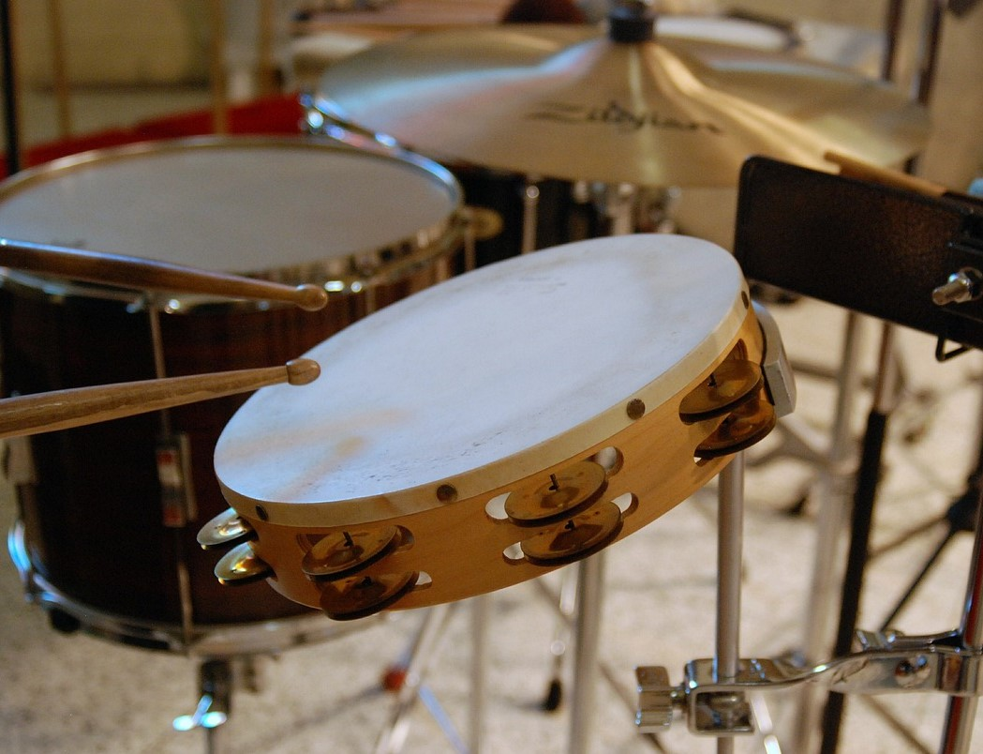

This is a very practical activity - you might like to use some musical instruments, for example a drum or a triangle, rather than using your hands and parts of your body.
Begin a rhythm: clap, clap, click (your fingers), clap, clap, click, clap, clap, click, clap, clap, click ...
What will you be doing on the 15th beat?
How do you know this without actually doing it?
What will you be doing on the 20th beat?
Again, explain how you can predict this.
How about on the 99th beat?
What would you be doing on the 100th beat?
If there is someone else with you, ask them to come and join in. If you're on your own, it doesn't matter, you'll just have to imagine that someone else is there.
You and your friend are going to both start a different rhythm at the same time.
You will do clap, clap, click, clap, clap, click ... as you did before.
Ask your friend to do click, clap, clap, click, clap, clap, click, clap, clap ...
Have a go so that you get a steady rhythm going.
If you both start at the same time, when will you both click your fingers at the same time?
Why?
Are there other ways that you could have clapped and clicked for this to be the case?
How could you change your rhythms so that you do click at the same time?
How could you predict when this was?

